Lab 6: A SPACE VOYAGE!!!!!!!
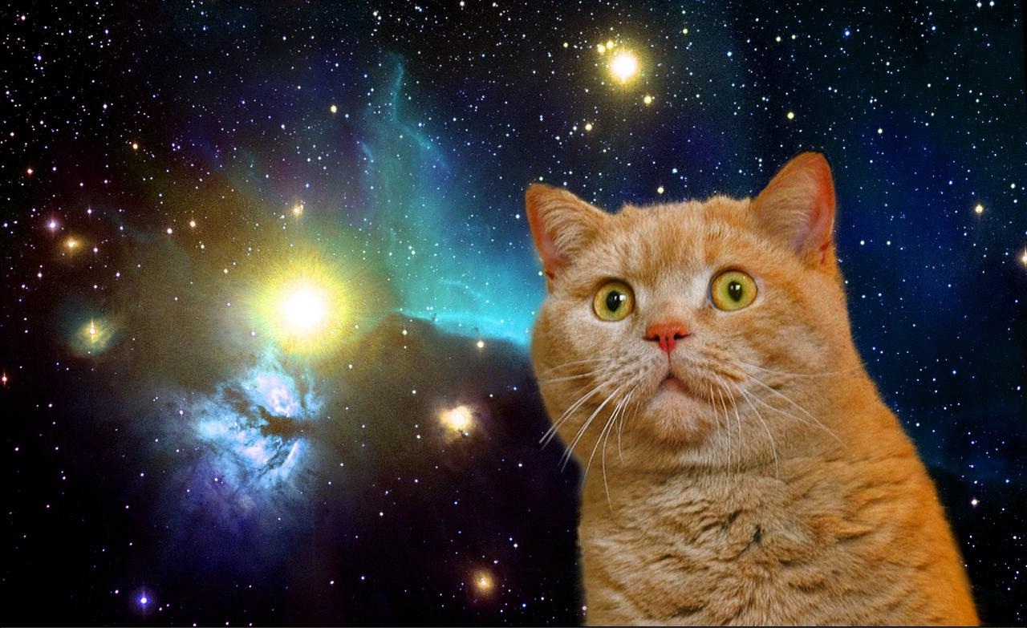Illustration 1: I HAZ SPACE SHIP, IT GOEZ FAST!1!

Overview:
We finally made it to lab 6 and this will serve as your end of the year project. Now that you have written a fully functioning simulator on your own, we are going to modify that simulator to run as a space voyage rather than a single orbit. Your task for this lab will be to visit the dark side of the moon (the side the earth cannot see) and return to the location in which your ship started.

This will not be an easy lab, so we will break up this lab over a six week period. The first three weeks I want you to try to write the program from the comment template I provide you. After those three weeks are up, we will pair up into groups and you will work together with a partner to finish the lab.

I will only provide the comment template and nothing else. This project is a culmination of every single python lab we have done up to this point, so feel free to reference you master folder for coding ideas. Furthermore, I will let you look at any of my solution code for each of the past five assignments. You may look at it and even write some of it down in your notebook, but you may not have a digital copy of the solutions. You can come see me towards the end of class or after school to examine the solutions on my computer.

We will also run in-class demos each week of my solution program so you know what to aim for in your own simulation. The end result should look like a space ship making a "figure-8" pattern around the moon and earth. There will be no parts to this handout past this overview. You will find the code template below. You will notice I gave you more help on this lab than the previous one. The reason I did this is because the physics in this lab is a bit more intense than the previous lab. Per the norm, please save your program as Lab6Final and I will collect it during lab class. Good luck on your final programming project!

from __future__ import division
from visual import*
from visual.graph import*
import numpy as np

#This will set the default window size, do not change!
scene.y = 300
scene.width = 400
scene.height = 1000

#Constants I have provided for you, DO NOT CHANGE THESE VALUES!!!
G = 6.7e-11
mEarth = 6.7e24
mCraft = 15e3
mMoon = 7e22
deltaT = 390
t = 0

#This variable will be used as a placeholder for spots in your code that must
#be writen over and updated.
x = 1.0

#Objects you should modify for your program
Earth = sphere()
Moon = sphere()
Craft = sphere()
Trail = curve()
pVector = arrow()
vCraft = vector(5077.5, 0, 0)

#Momentum: assign pcraft a mathematical statement for momentum.
pCraft = x

#Graph Information I have provided.
Kgraph = x
Ugraph = x
KplusUgraph = x

while t < 1000000:
#This will slow down the animation
rate(250)
#Momentum arrow updated by the craft position

#Earth-Craft position vector

#Magnitude of Earth-Craft position Vector

#Unit vector for r in Earth-Craft direction

#Magnitude of gravitational force from Earth-Craft system

#Gravitational force from Earth-Craft system

#Moon-Craft position vector

#Magnitude of Moon-Craft position vector r

#Unit vector for r in Moon-Craft direction

#Magnitude of gravitational force from Moon-Craft system

#Gravitational force from Moon-Craft system

#Craft velocity

#Craft momentum

#Updates the direction the arrow points

#Craft kinematic equation.

#This leaves a trail behind the spacecraft

#Kinetic Energy

#Potential Energy

#Kinetic Energy plot

#Potential Energy Plot

#Total Mechanical Energy Plot

#Time increment
t = t + deltaT

